**Corruption, bribery, theft and tax evasion** cost some US $1.26 trillion for developing countries per year; this amount of money could be used to lift those who are living on less than $1.25 a day above $1.25 for at least six years.

## 16.4

By 2030, significantly reduce illicit financial and arms flows, strengthen the recovery and return of stolen assets and combat all forms of organized crime

**16.4.1**

Total value of inward and outward illicit financial flows (in current United States dollars)

**16.4.2**

Proportion of seized, found or surrendered arms whose illicit origin or context has been traced or established by a competent authority in line with international instruments

### Illicit financial:

#### Definition

Illicit financial flows (IFFs) are illegal movements of money or capital from one country to another. GFI classifies this movement as an illicit flow when the funds are illegally earned, transferred, and/or utilized.

#### Data

[GFI estimates](http://www.gfintegrity.org/report/illicit-financial-flows-from-developing-countries-2004-2013/) that in 2013, US$1.1 trillion left developing countries in illicit financial outflows. This [estimate](http://www.gfintegrity.org/issues/illicit-financial-flows-analytical-methodologies-utilized-global-financial-integrity/) is regarded as highly conservative, as it does not pick up movements of bulk cash, the mispricing of services, or many types of money laundering.

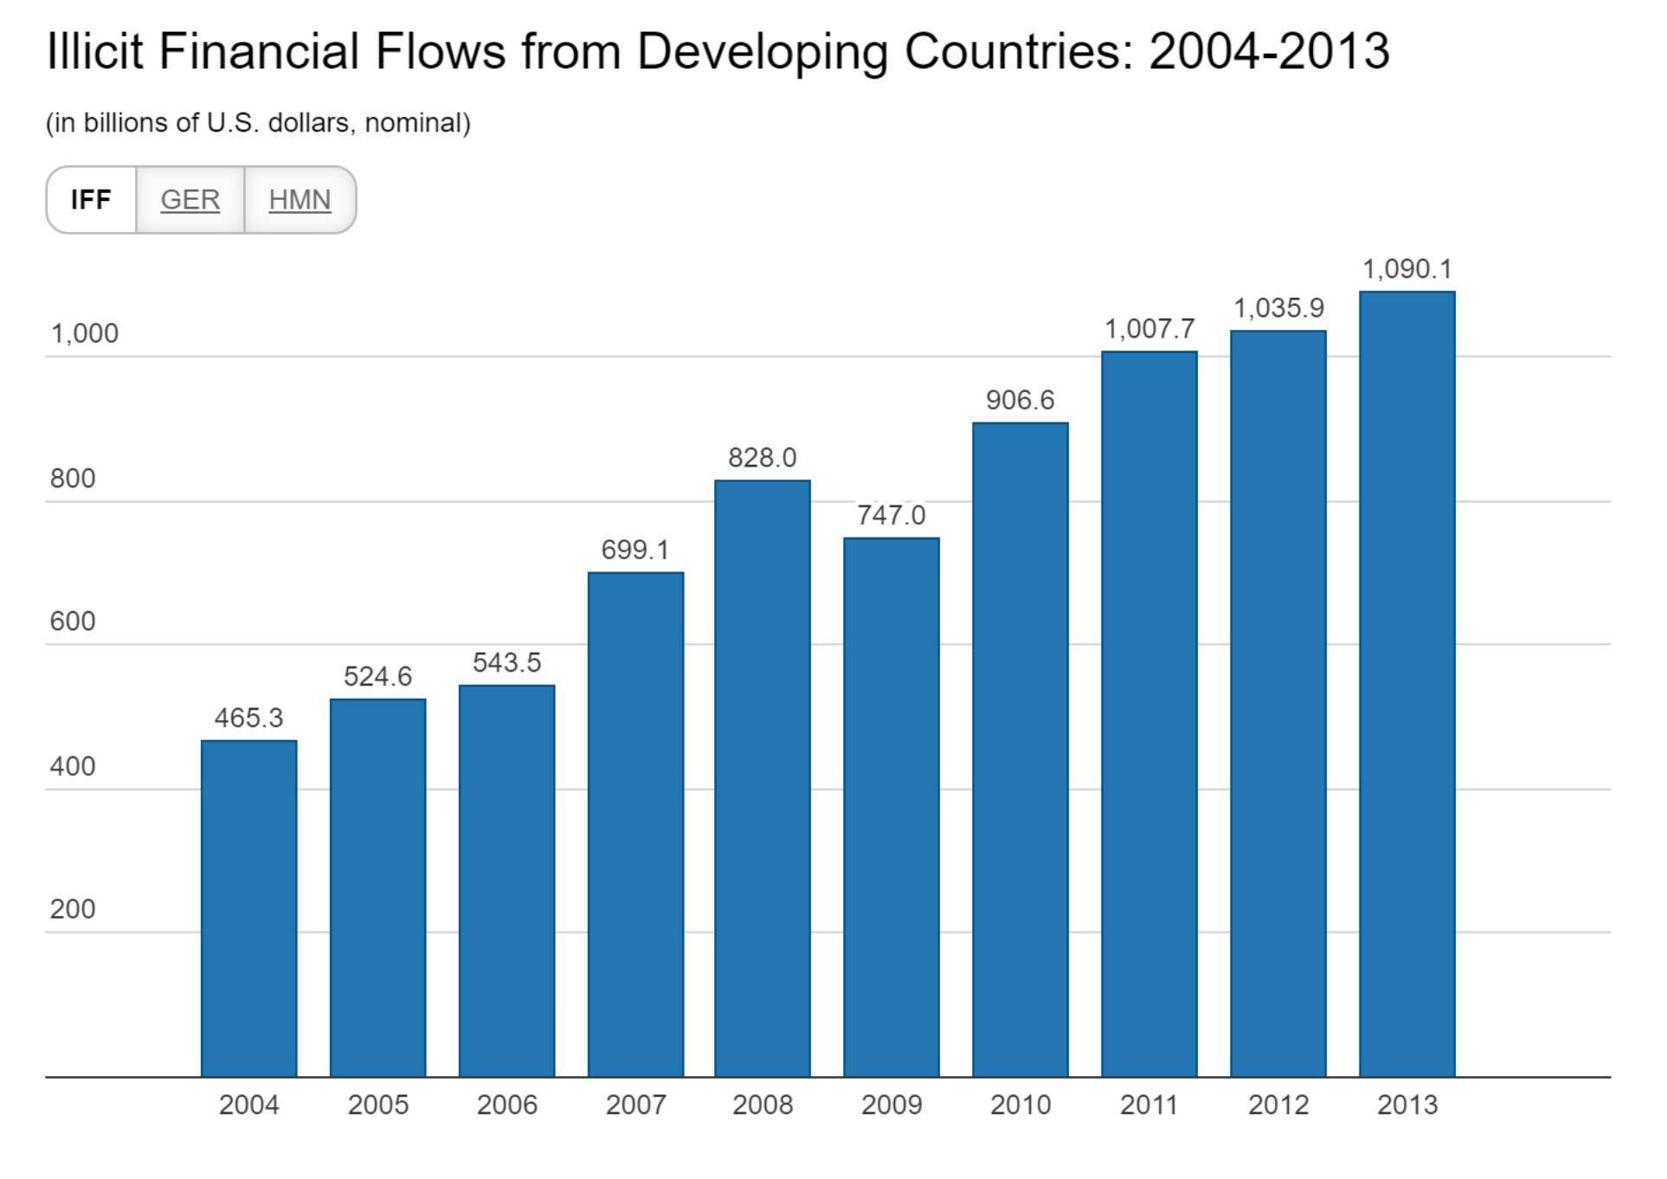

#### Impact

US$1.1 trillion is a tremendous amount of money to drain out of developing countries. A 2013 GFI report found that even after you account for all types of financial flows (both legitimate and illegitimate)—including investment, remittances, debt forgiveness, and natural resource exports—Africa is a net creditor to the world:

GFI is currently in the process of applying this analysis of “Net Resource Transfers” to the rest of the developing world.

Beyond the damaging economic impact of the overall capital outflows, illicit financial flows have a terrible, subversive impact on governments, victims of crime, and society. They facilitate transnational organized crime, foster corruption, undermine governance, and decrease tax revenues.

#### Where Does the Money Go?

Every dollar that leaves one country must end up in another. Very often, this means that illicit financial outflows from developing countries ultimately end up in banks in developed countries like the United States and United Kingdom, as well as in tax havens like Switzerland, the British Virgin Islands, or Singapore. GFI research suggests that about 45% of illicit flows end up in offshore financial centers, and 55% in developed countries.

This does not happen by accident. Many countries and their institutions actively facilitate—and reap enormous profits from—the theft of massive amounts of money from developing countries. GFI believes that **developed countries have a responsibility alongside developing countries to curtail the flow of illicit money.**

#### What Can We Do?

GFI believes that the most effective way to limit illicit financial flows is to **increase financial transparency**. GFI believes that we should enact policies to:

* Detect and deter cross-border tax evasion;
* Eliminate anonymous shell companies;
* Strengthen anti-money laundering laws and practices;
* Work to curtail trade misinvoicing; and
* Improve transparency of multinational corporations.

<https://www.gfintegrity.org/issue/illicit-financial-flows/>

#### Economics consequences

There is broad consensus amongst multilateral development banks that most developing countries are unable to mobilize enough domestic investment capital to ensure robust, long-term economic growth (cf. Ndikumana, 2013; critical: Easterly, 1999). Not least, public investment funds are scarce for the funding of infrastructure and social policy measures for poverty alleviation (AfDB et al., 2012, 69ff.). As the African Development Report 2012 underlines, one of the major impacts of IFFs is that they further widen these funding deficits:

‘Investment is one of the most important conduits through which capital flight affects human development. If flight capital was saved and invested in the domestic economy of the country of origin it would increase income per capita and help to reduce poverty. In Nigeria and Angola, for example, this would imply additional investment of USD 10.7 billion and USD 3.6 billion per year, respectively in the period 2000 to 2008.’ (Ibid., 79)

29It would be a mistake to assume, however, that there is a one-to-one relationship between IFFs and investment losses. IFFs sometimes facilitate round-tripping and immediately return to the country of origin supposedly as foreign direct investment (TJN, 2007, 18f.).[7](https://journals.openedition.org/poldev/1863#ftn7) As stressed by Blankenburg and Khan (2012), some types of IFF can moreover lead to additional capital inflows into the country of origin. Examples of this would be IFFs that facilitate labour migration and ultimately increase inflows of remittances.

The amount of capital that flows back into the countries of origin would on average be markedly less than the original outflows however. In an empirical study of thirty-nine African developing countries from 1970 to 2010, Ndikumana (2013) demonstrates that IFFs (weighted according to the size of the economy concerned) have a robust and — despite the problems of measurement plaguing IFF estimation in all cases — a statistically significant investment-inhibiting effect. What is, however, interesting is that this effect concerns private investment first and foremost, whereas the impact on public investment turns out to be insignificant. According to Ndikumana, the reason for this difference is that the funding gaps IFFs create in public investment can sometimes be offset by foreign development funding and in particular by further public borrowing.

31By and large, it may be considered an empirical fact that there is a close connection between IFFs and the public debt ratio. The connection works both ways, of course (Ndikumana and Boyce, 2003; Beja, 2006). Hence, IFFs can force the governments concerned to resort to flight-driven external borrowing. Conversely, foreign loans can also serve to trigger debt-fuelled capital flight. In this case, loans that have been contracted or guaranteed by the government flow immediately and directly into foreign private accounts. In both cases, IFFs compound government indebtedness and hence dependence on foreign aid — together with its implicit and explicit policy conditionalities.

To gauge the extent to which the investment-inhibiting effect of IFFs impacts economic growth, Ndikumana (2013) used data from a number of African developing countries to conduct an econometric simulation. The central question of the counterfactual study is how much additional growth the affected countries might have achieved without illicit financial outflows. The findings are of course plagued by a number of uncertainties, but the trend is impressive.[8](https://journals.openedition.org/poldev/1863#ftn8)  Ndikumana concludes that the thirty-nine countries studied over the period from 2000 to 2010 might have been able to achieve on average 3 per cent more economic growth had there been a radical stop to all IFFs. In oil-exporting countries, which are especially prone to illicit financial outflows, that additional growth might even have been 3.9 per cent.

Ndikumana’s simulation makes the basic assumption that IFFs could be 100 per cent productively invested in the country of origin. This seems just as unrealistic as the assumption that all IFFs could be radically stopped. In this regard, the simulation could *over*estimate the growth effect that would actually result from drastic measures to limit IFFs. At the same time, the author overlooks the fact that a significant reduction in IFFs could lead to significant improvements in the quality of infrastructure and public institutions (see below). This would positively impact not only the level of domestic investments, but also the growth they would bring about. In his model’s calculations, Ndikumana nevertheless assumes that there is a constant growth yield from each unit invested. Hence, his simulation could also markedly *under*estimate the additional growth that would result from effectively halting IFFs.

<https://journals.openedition.org/poldev/1863>

### Illicit arms flow

<https://www.sipri.org/commentary/topical-backgrounder/2018/sdg164-and-collection-data-illicit-arms-flows-progress-made-challenges-ahead>

## 16.5

Substantially reduce corruption and bribery in all their forms

**16.5.1**

Proportion of persons who had at least one contact with a public official and who paid a bribe to a public official, or were asked for a bribe by those public officials, during the previous 12 months

**16.5.2**

Proportion of businesses that had at least one contact with a public official and that paid a bribe to a public official, or were asked for a bribe by those public officials during the previous 12 months